Bekdaulet Aklima – Lab 2

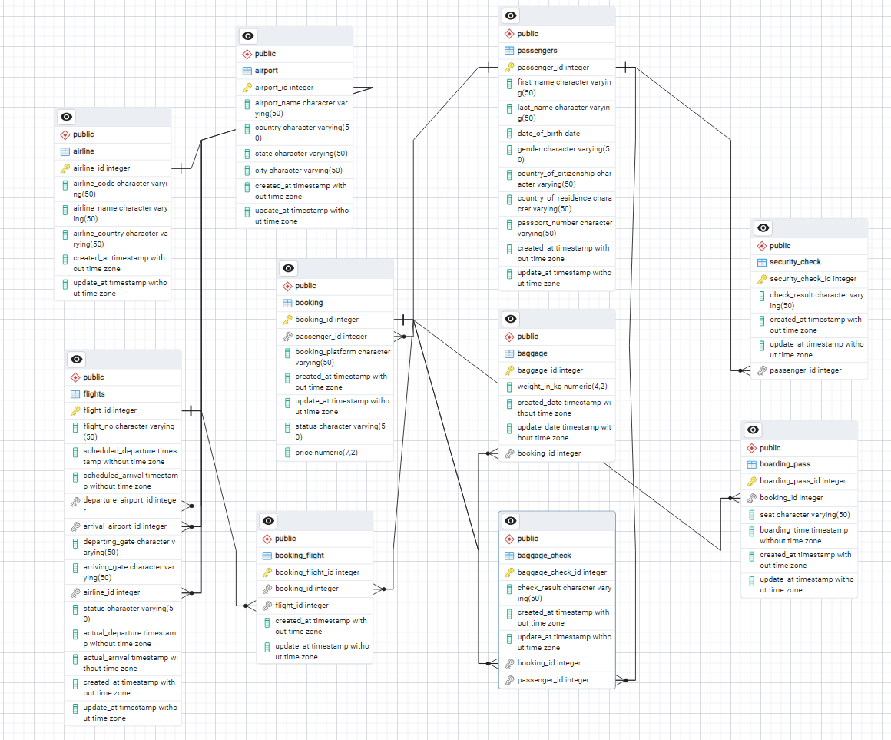Make a relationship between following tables **(20%):** - Passengers with Secuitiry_check, Booking, Baggage_check by passenger_id; 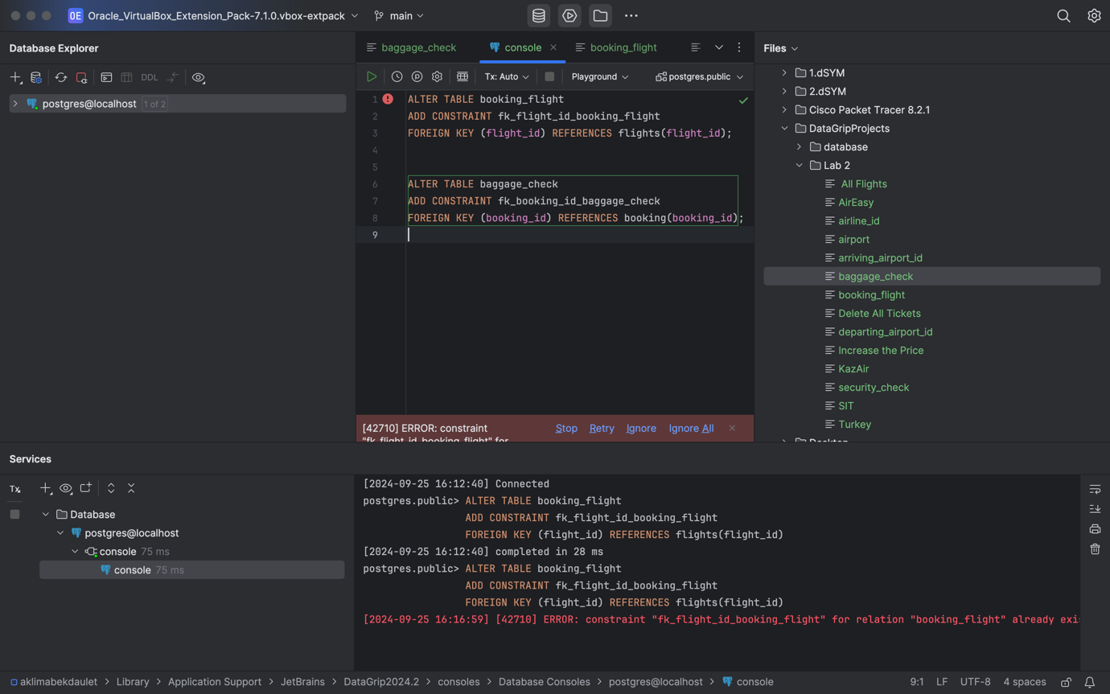

-Booking with Baggage_check, Baggage, Boarding_pass, Booking_flight by booking_id;

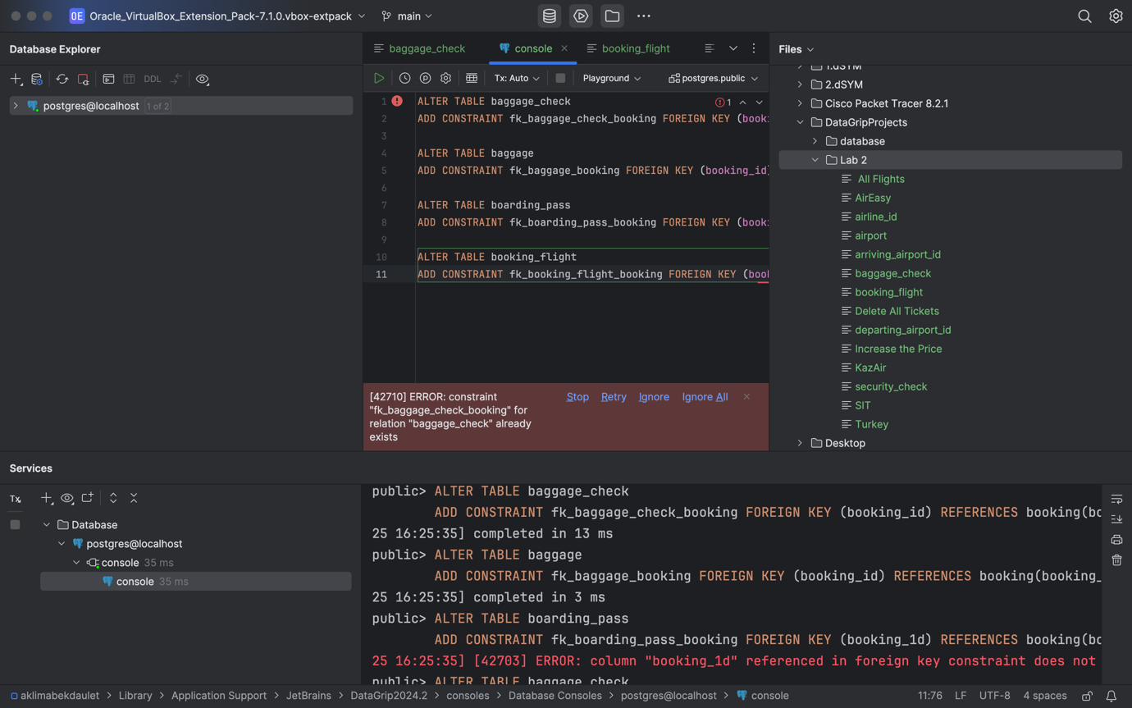

- Flights with Booking_flight by flight_id;

- Airport with Flights by departing_airport_id;

- Airport with Flights by arriving_airport_id;

- Airline with Flights by airline_id;

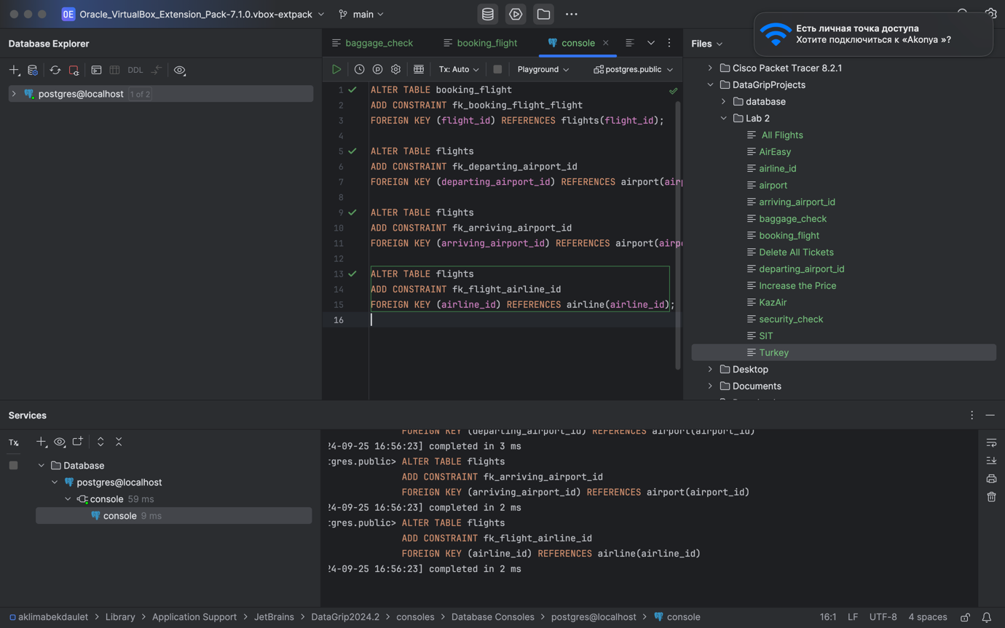

**DML – Data Manipulation Language**

Generate and insert 100 random rows in your airport database using mockaroo service

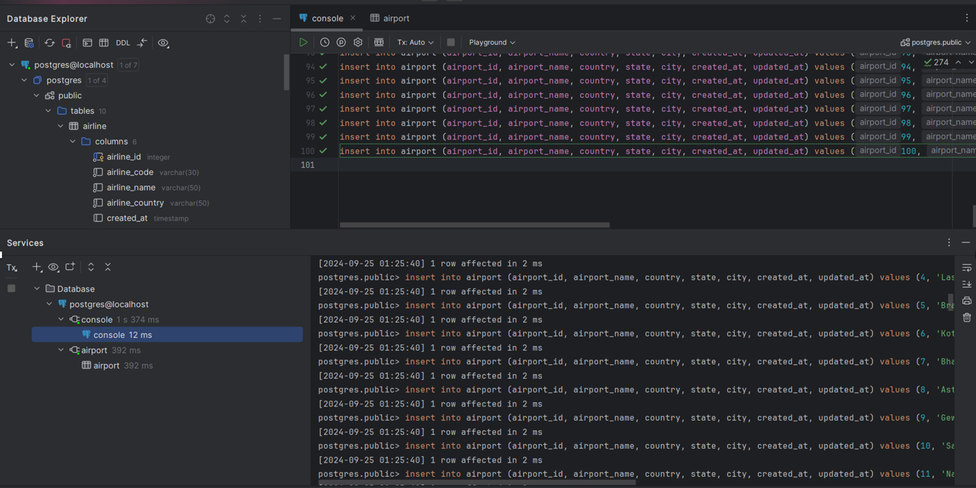

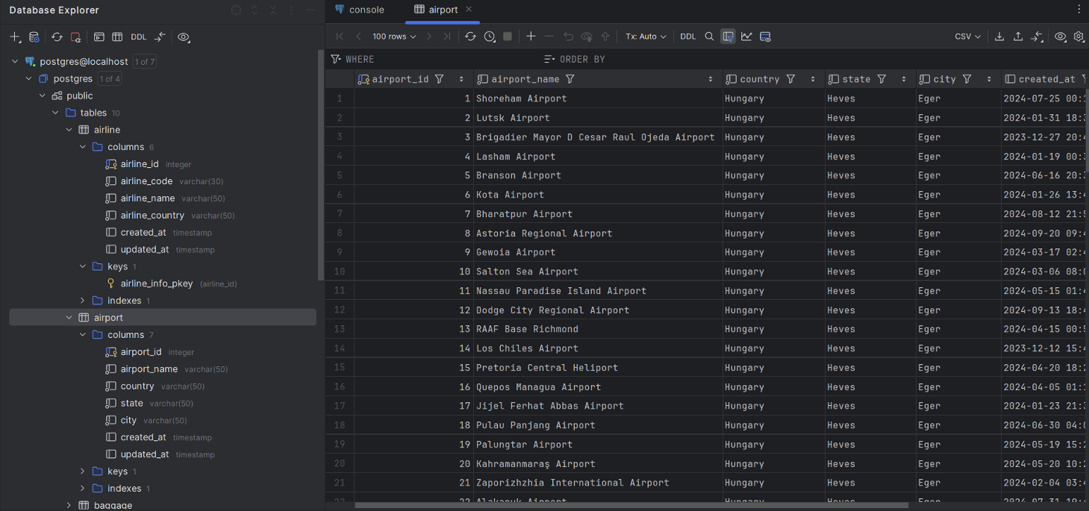

2. Add a new airline named "KazAir" based in "Kazakhstan" to the airline table 1**0%**

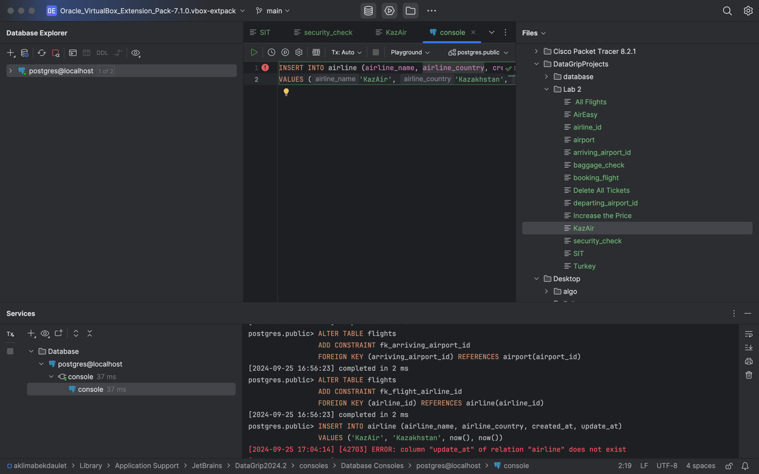

Update the airline country "KazAir" to "Turkey".(**10%** )

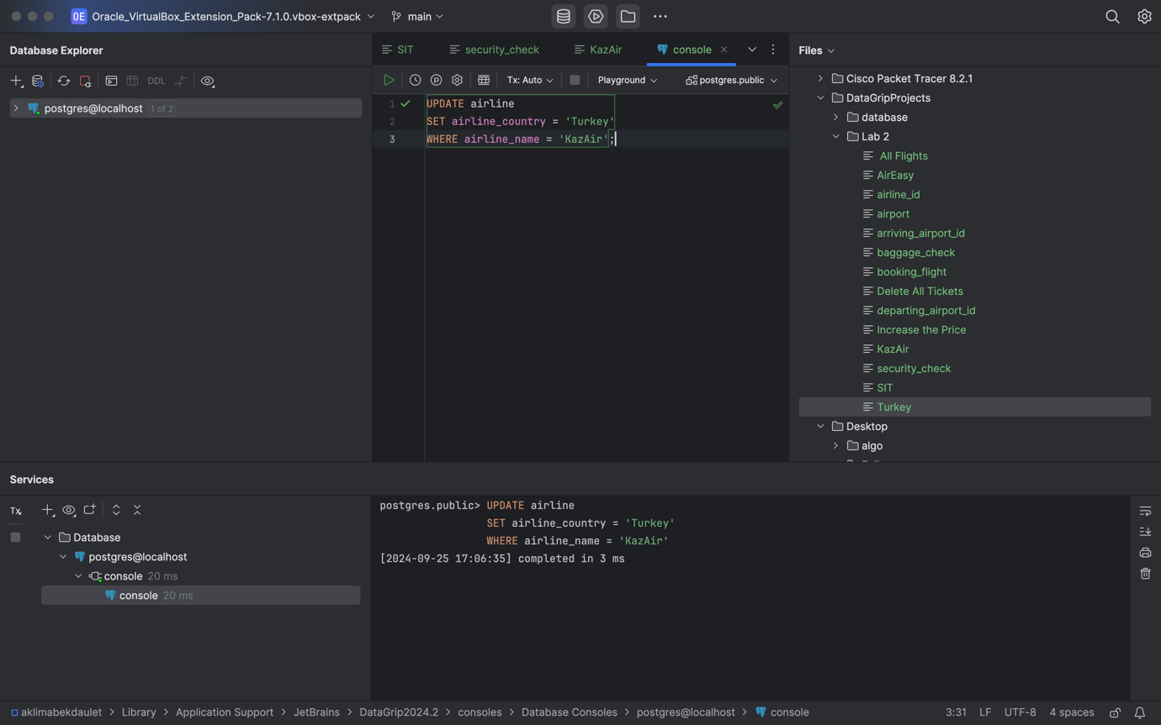

4. Remove the airline named "SIT" from the airline table. (**10%**)

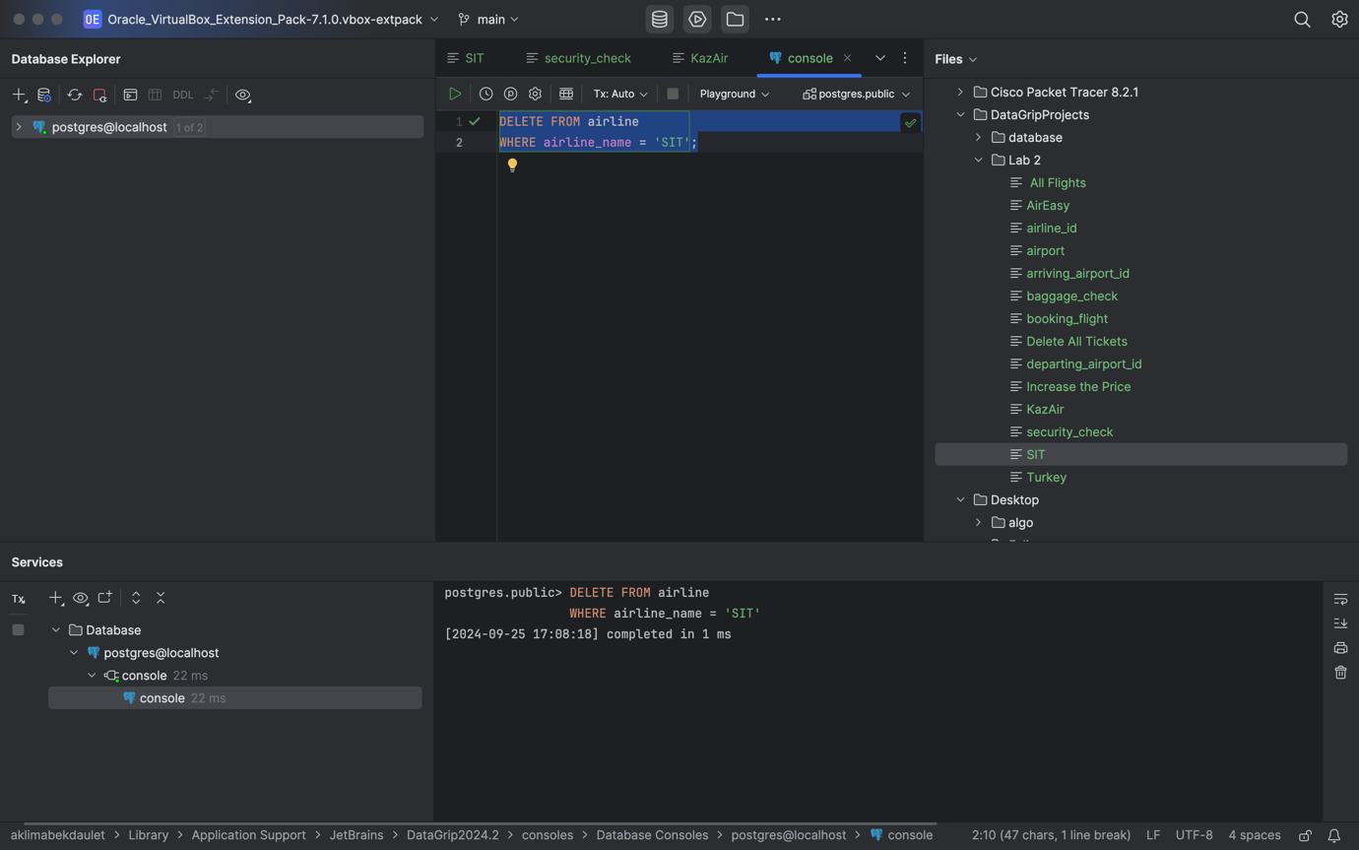

5. Add three airlines at once: "AirEasy" in "France", "FlyHigh" in "Brazil" and "FlyFly" in "Poland". (**10%**)  
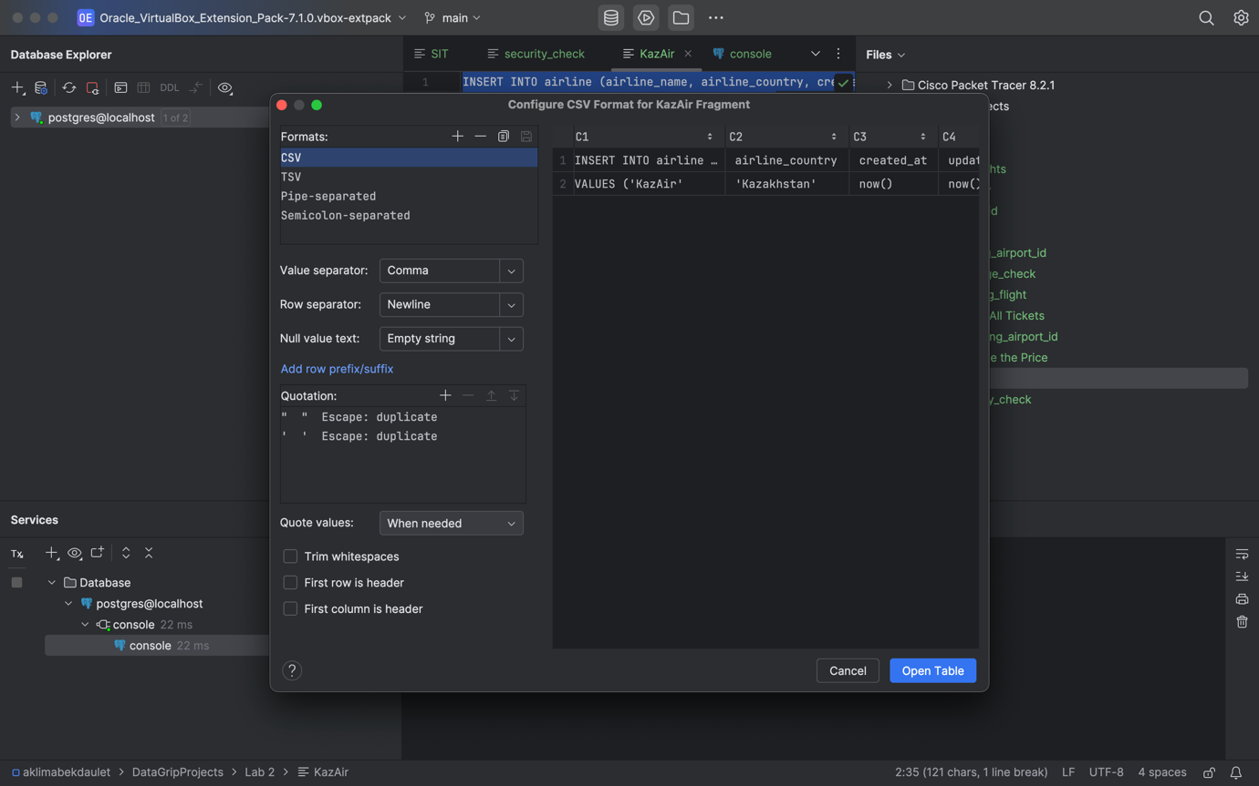

6. Delete all flights whose arrival in 2024 year. (**10%**)

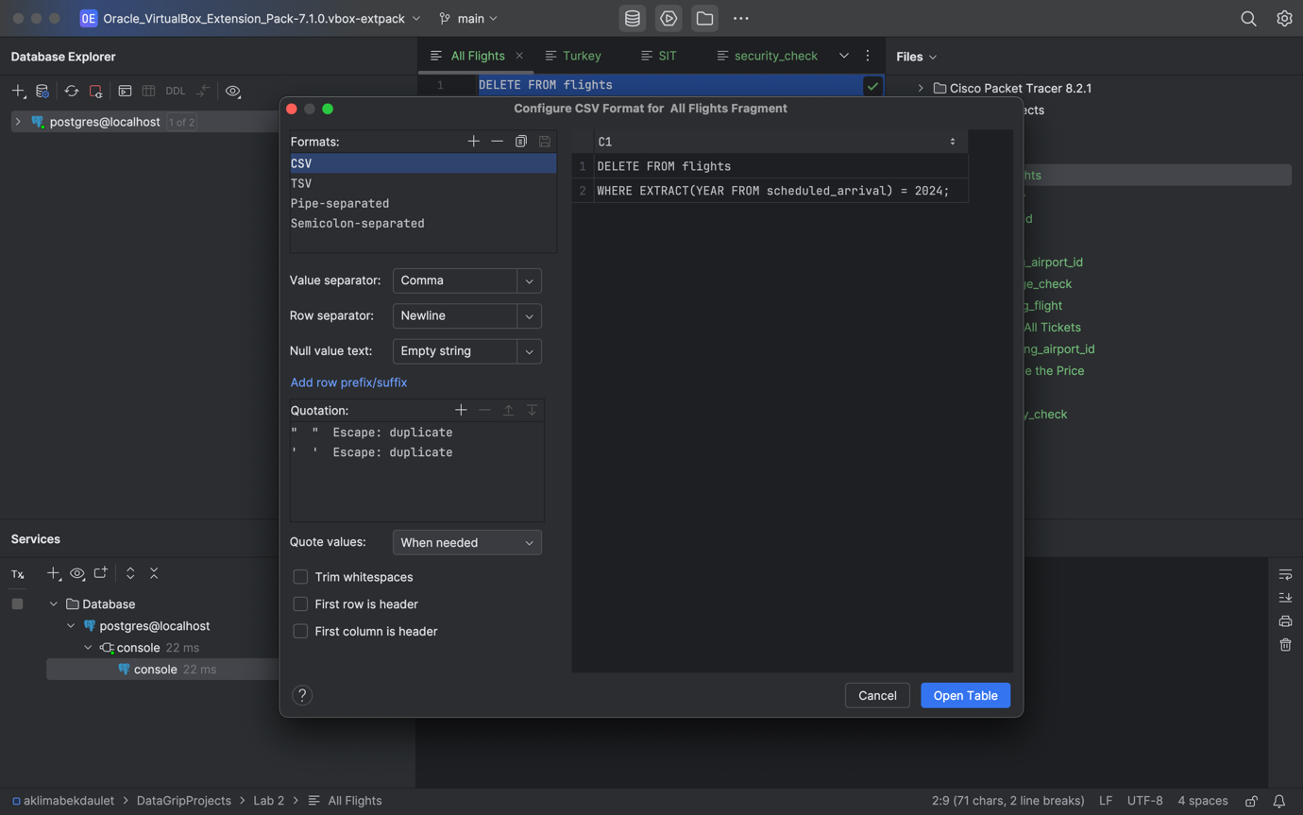

7. Increase the price of all tickets in booking table for flights by 10%

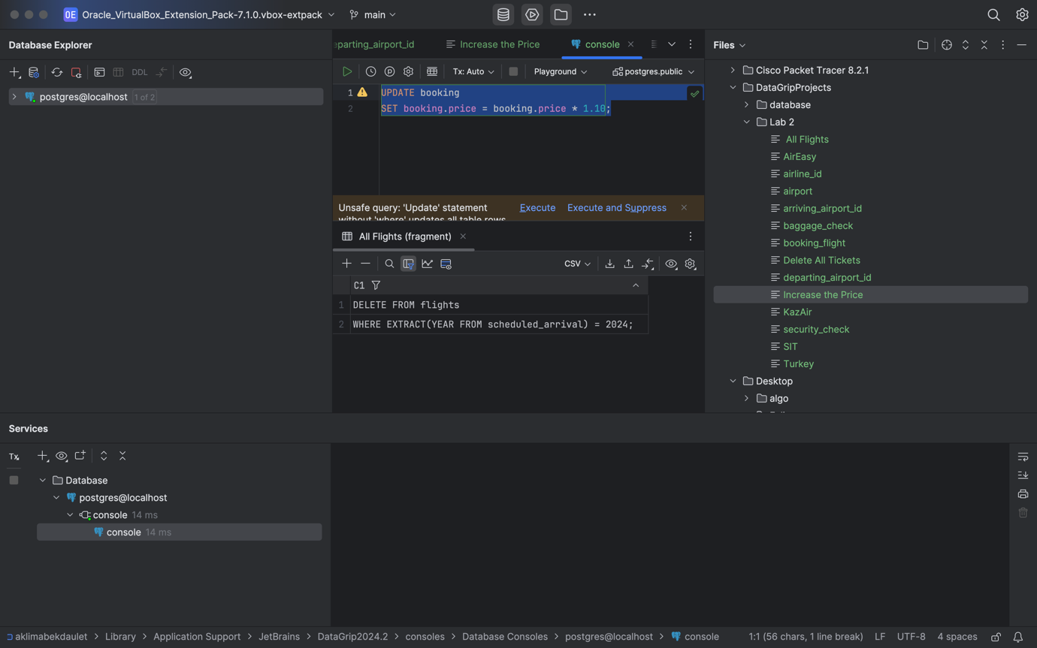

8. Delete all tickets whose price is less than 1000 units. (**10%** )

